PROJECT: - ONLINE E-SHOPPING

1. Name- SHOVAN MAITY

Mail- [shovan.cse91@gmail.com](mailto:shovan.cse91@gmail.com)

Mob. No.- 9564743007

Enroll id- HPER-123184

Student id- 108049

1. Name- TARKESHWAR PRASAD

Mail- tp11081994tp@gmail.com

Mob. No. - 9614438662

Enroll id- HPER-124920

Student id- 109578

1. Name- SAURABH KUMAR

Mail- saurabh3434@gmail.com

Mob. No.- 9614787402

Enroll id- HPER-123182

Student id-108047

1. Name- AYAN MONDAL

Mail- ayan1995mondal@gmail.com

Mob. No.- 8509953835

Enroll id- HPER-123000

Student id- 107890

1. Name- RAHUL SONTHALIA

Mail- rahulsonthalia@gmail.com

Mob. No.- 9163592037

Enroll id- HPER-124856

Student id- 109516

Pages:-

1. Signup/Login
2. Forgot password page
3. Home page
4. Product view page
5. Cart page
6. Payment page

Databases-

1. online_shopping

* product table
* user table

**Signup/Login Page:-**

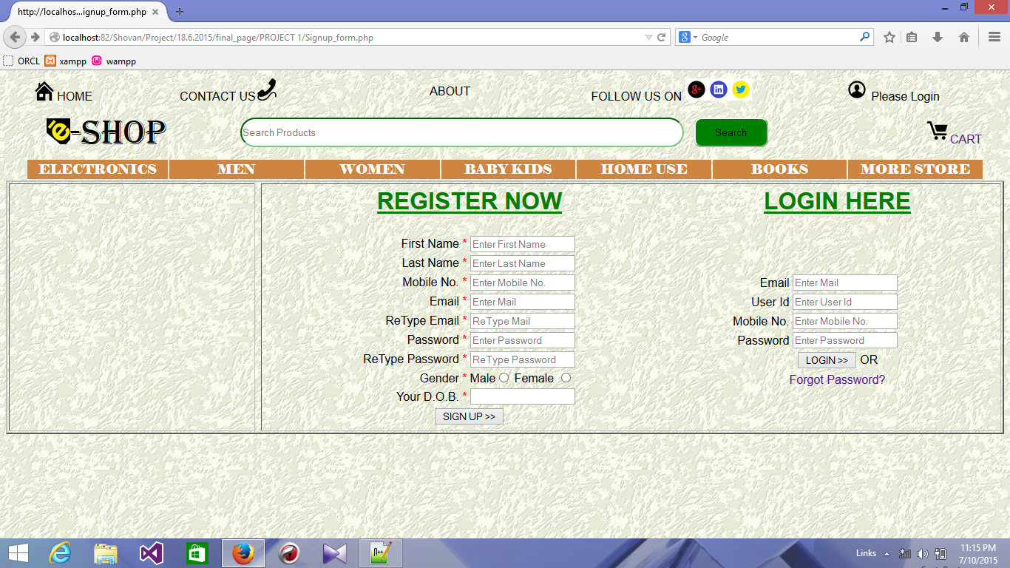

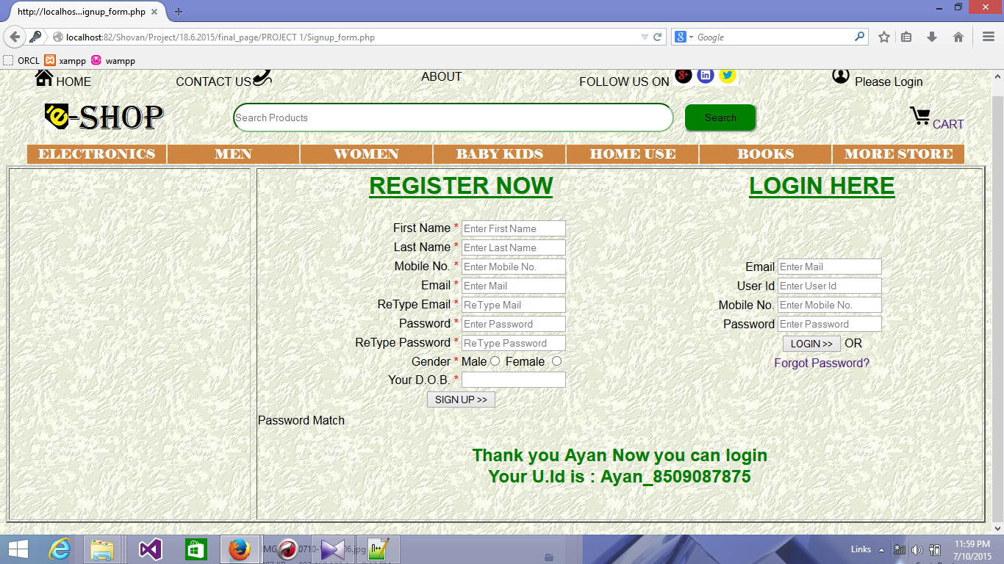

**Forgot password page:-**

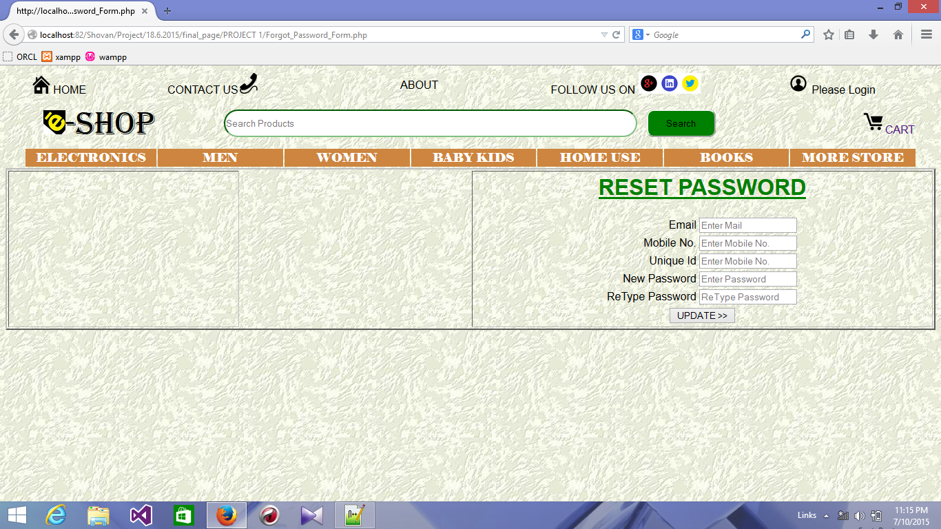

**Home page:-**

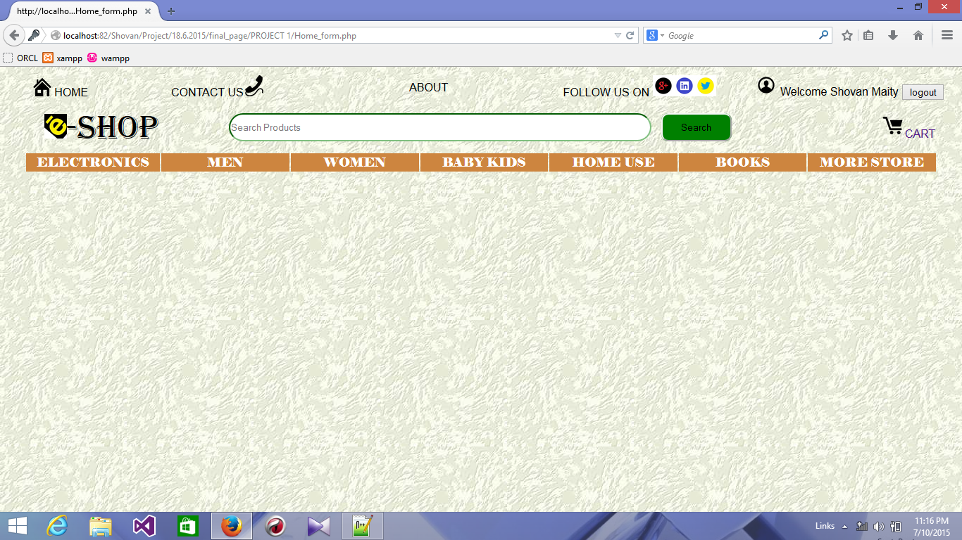

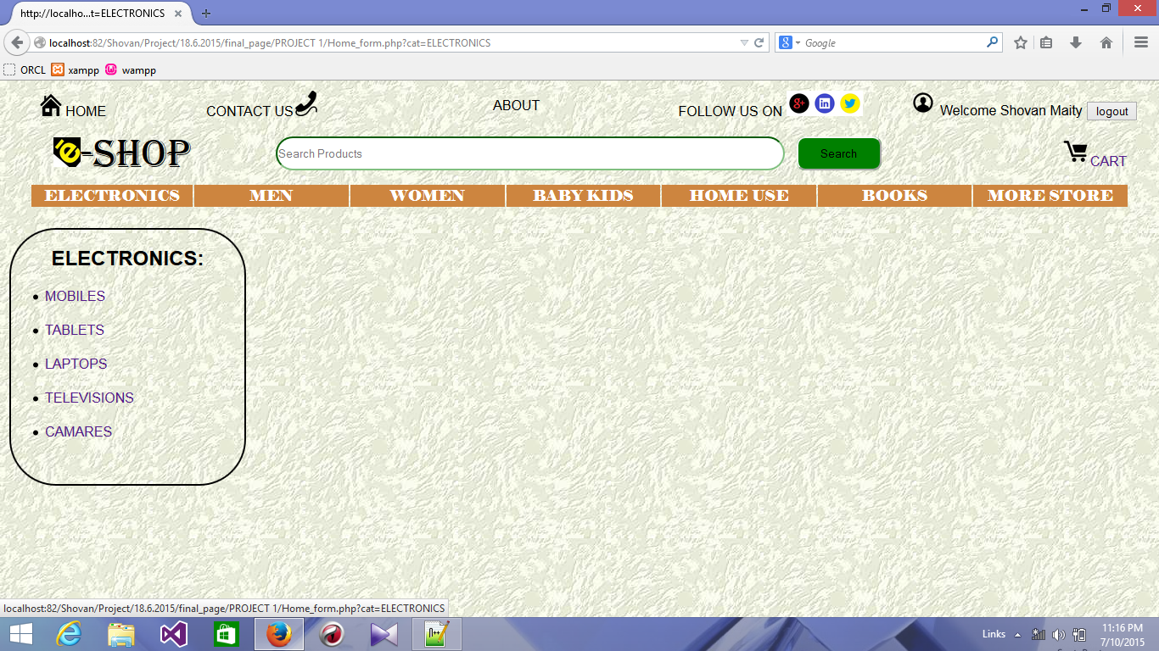

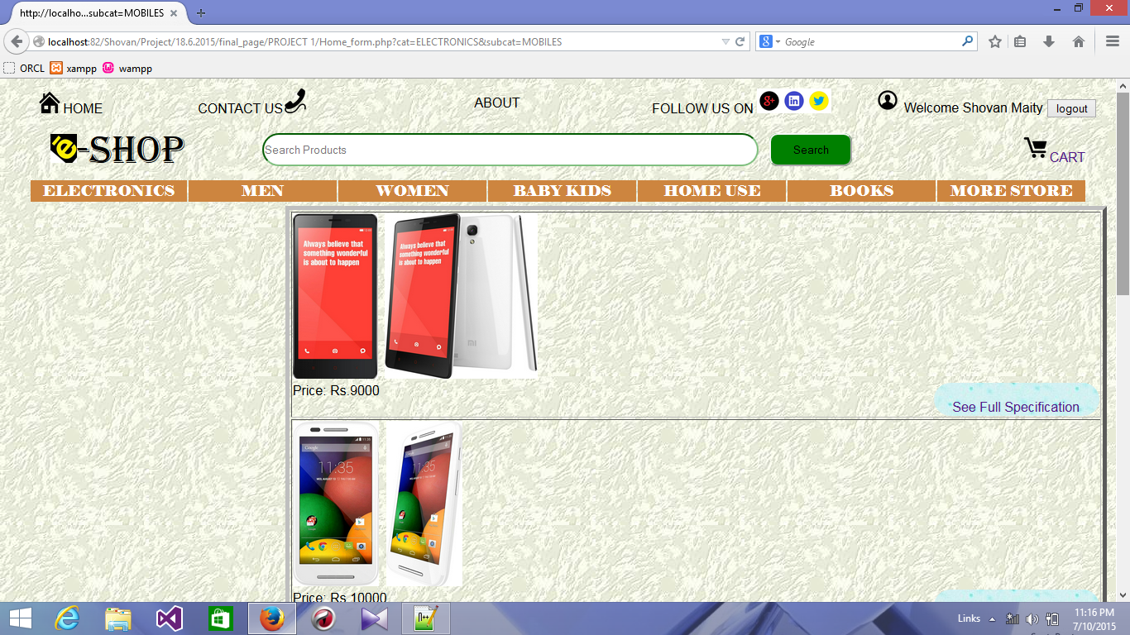

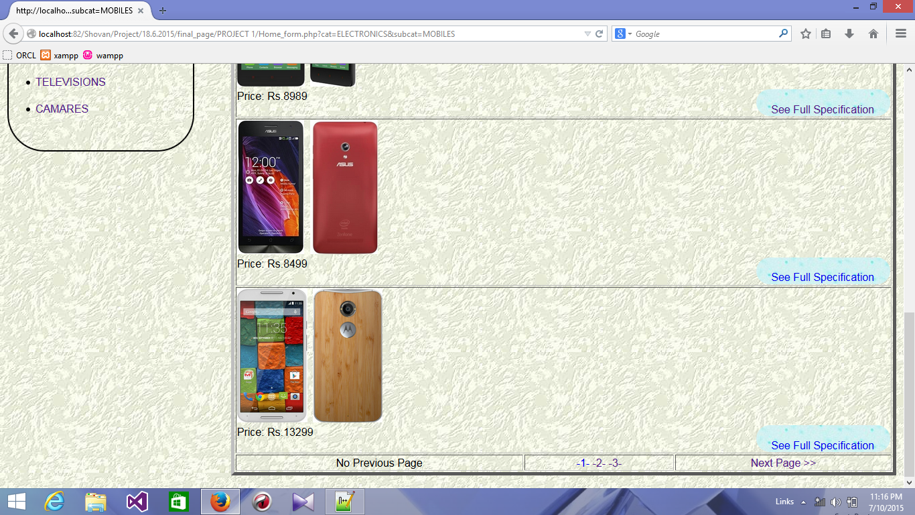

**Product view page:-**

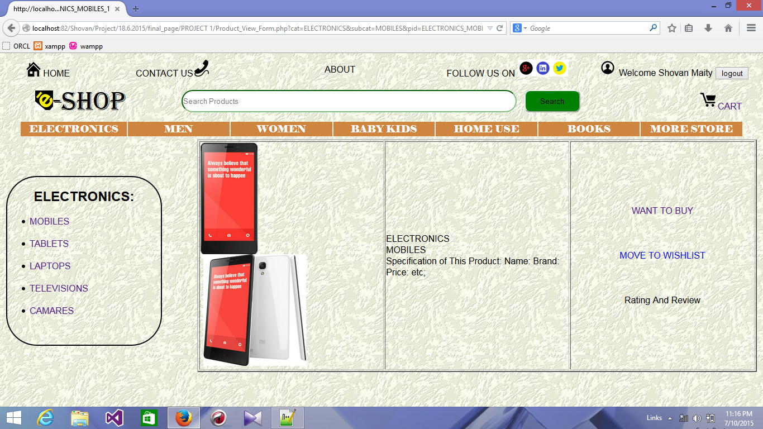

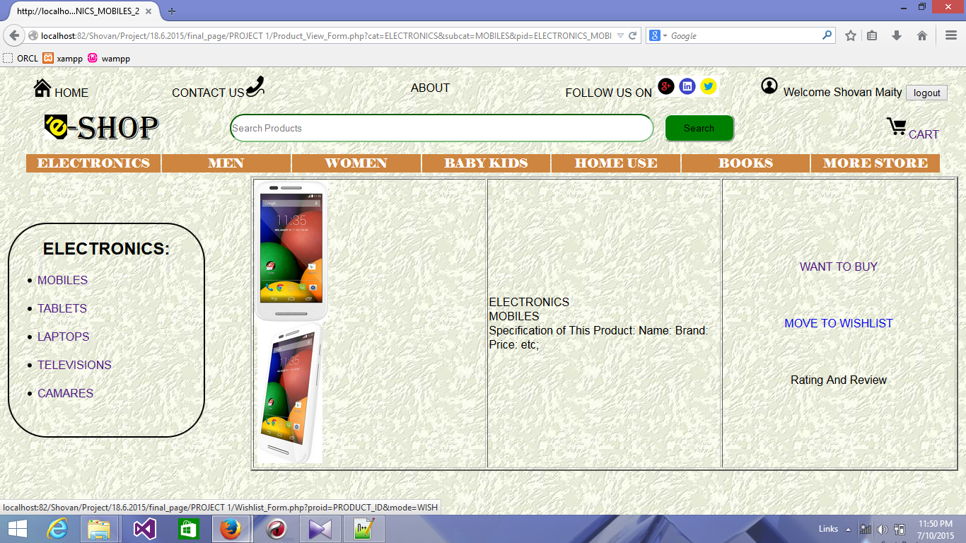

**Cart page:-**

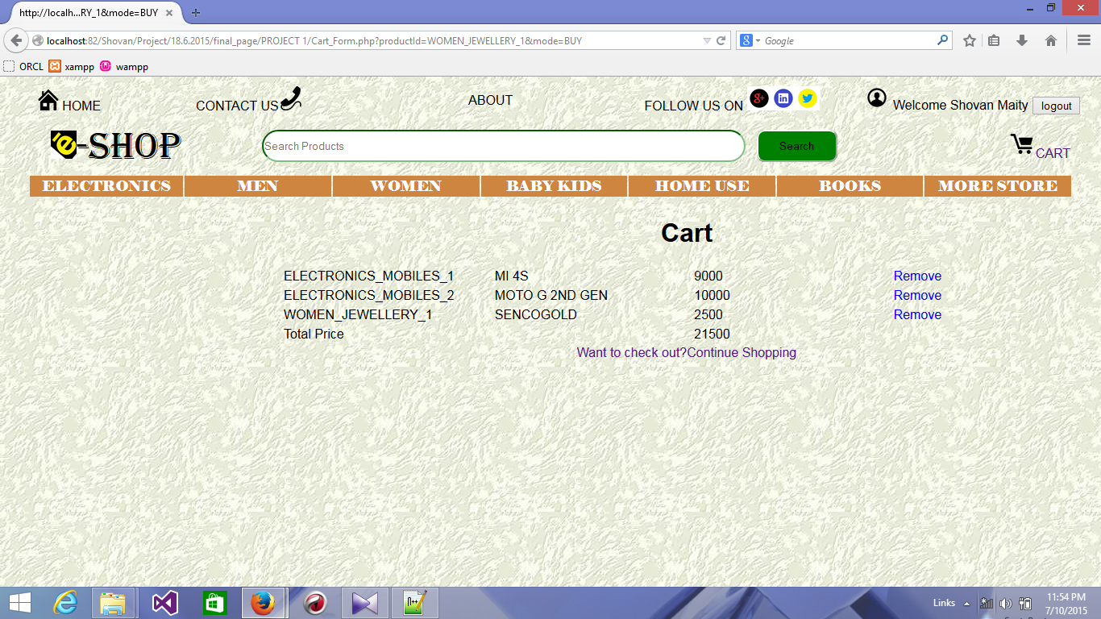

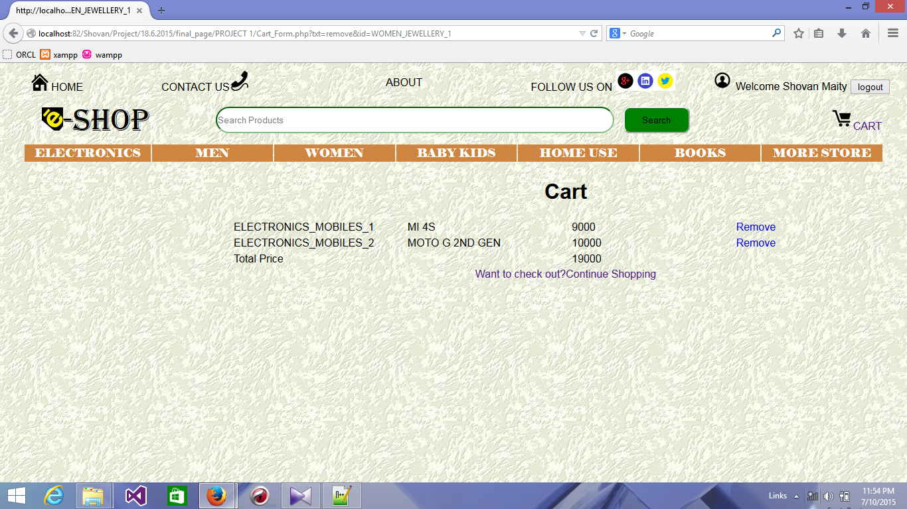

**Payment Page:-**

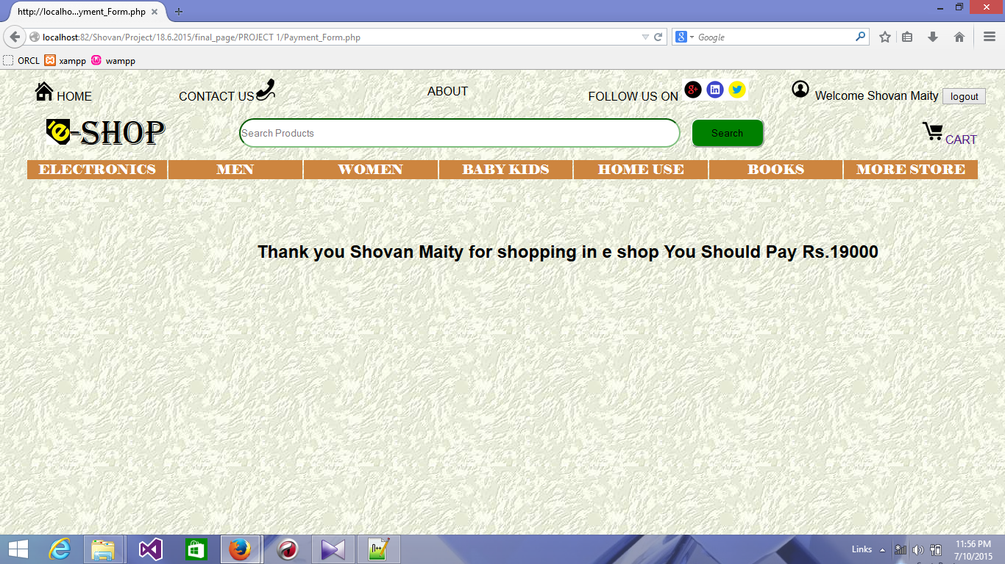

**Databases:-**

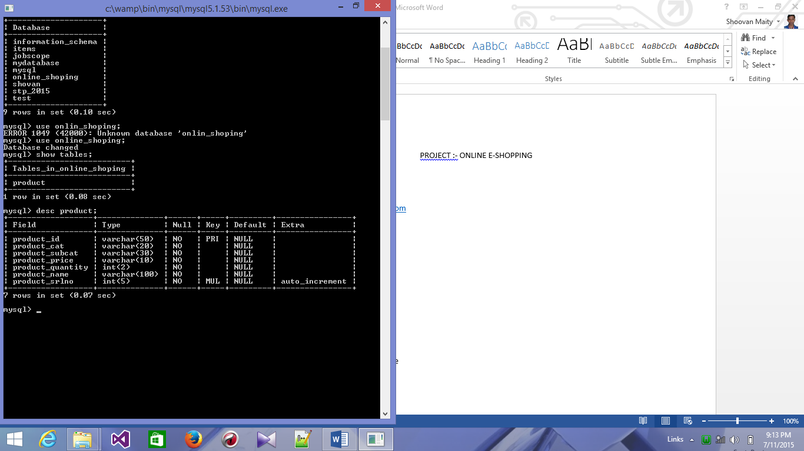

**2.**

